Note Nine

* Non-linear regression function
  + Relation between x and y is nonlinear
    - The marginal effect of X is not **constant**
  + Assumptions
    - Same as the four assumptions of multiple regressors function
  + Solutions
    - 1
      * Polynomials in x
      * 
      * 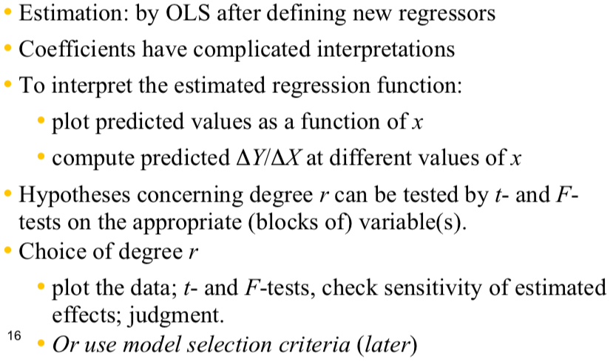
    - 2
      * Log transformation
      * 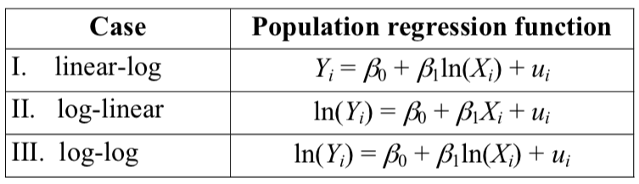
* Linear log
  + 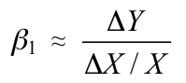
  + 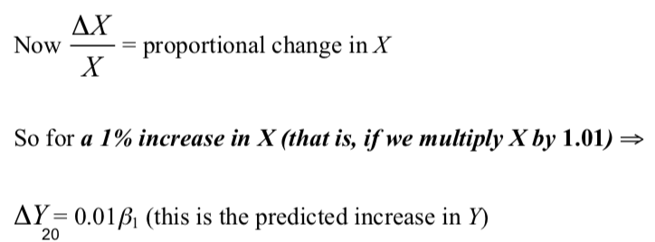
  + Eg
    - For every 1 percent increase of income, the test score will increase by 0.36 points
* Log linear
  + 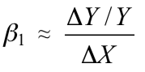
  + 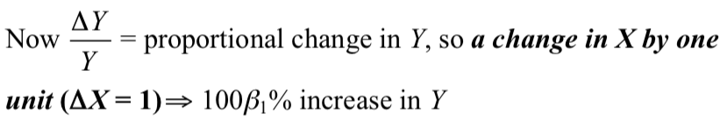
  + Eg
    - For one dollar increase of income, the test score will increase by 3642 percent
* Log log
  + 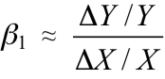
  + 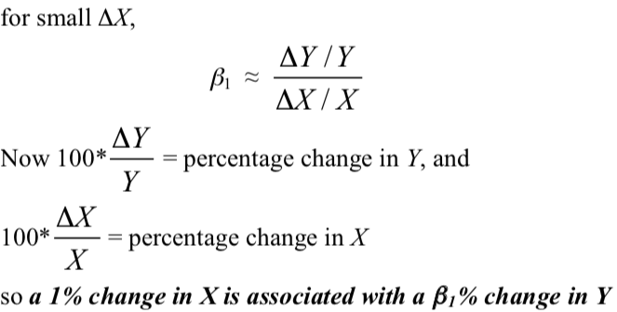
  + In log log, ß1 has the interpretation of an elasticity
  + Eg
    - 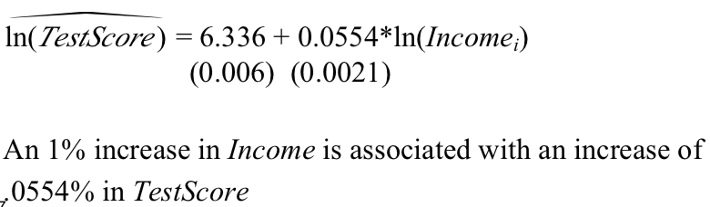
  + Eg
    - 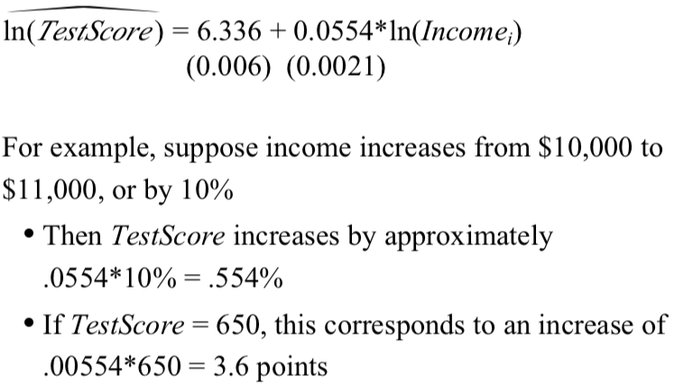
* Interaction between continuous variable and binary variable
  + Use F-test
  + Analyze nonlinear effect?